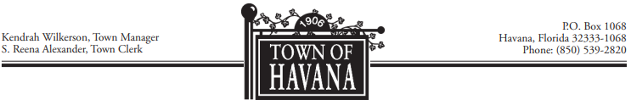

TOWN OF HAVANA
Regular Council Meeting Agenda
February 2024

Meeting Location Meeting Date/Time
Cecil G. Trippe Municipal Building February 27, 2024
Council Chambers 6:00 P.M.
711 North Main Street
Havana, Florida 32333

Call to Order
- Invocation & Pledge of Allegiance

Roll Call
- Group 1 – Penny Key
- Group 2 – Tabatha Nelson
- Group 3 – Matt Wesolowski
- Group 4 – Nick Bert
- Group 5 – Lawrence Reed
- Group 6 – Eddie Bass, Mayor Pro Tem
- Group 7 – Tim Loughmiller, Mayor

Recognition of Visitors
- Any visitor wishing to address the Council will limit comments to three minutes.

Request to Approve Minutes
- January 30, 2024

Old Business

Item #01
- Old Elementary School Resolution 2024-14R-2

New Business

Item #02
- FMEA Award – Mutual Aid

Item #03
- Fire Department Extension & Contract Update

Item #04
- Gadsden United Municipal Association Resolution 2024-04R

Item #05
- American Legion Post 84 – Hazel Baker Request

Item #06
- Water Projects – ARPA Funding

Item #07
- MSCOP Grant – Resolution 2024-02R for Paving Project 5th Street SE

Item #08
- March 29 – Good Friday – Request to close Town Hall

Item #09
- Municipal Election Day April 30th – Request to move Council Meeting

Item #10
- Vulnerability Assessment – Contract for Services

Item #11
- Special Events Permit Request – Havana Family Fun Day

Item #12
- Special Events Permit Request – Arts & Crafts Festival

Report of the Town Manager
Recognition of Each Council Member
Motion to Pay the Bills
Motion to Adjourn

