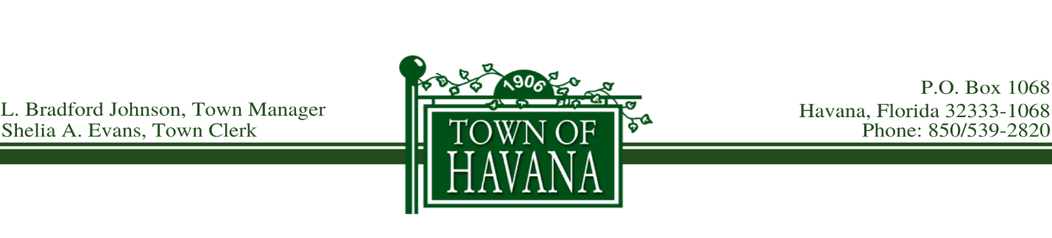
Agenda
First Public Budget Hearing
September 8, 2021 @ 5:30 p.m.

Call to order by Mayor Hart

Invocation

Pledge of Allegiance

Town Manager Budget Amendment Recommendations

First Reading of Ordinance No. 389, Proposed Ad Valorem Tax Rate

Recognition of any visitor(s) who would like to address the Council on the Ad Valorem Tax Rate

Approve First Reading of Ordinance No. 389

First Reading of Ordinance No. 390, Proposed Budget for 2021 - 2022

Recognition of any visitor(s) who would like to address the Council on the Proposed Budget

Approve First Reading of Ordinance No. 390

Motion to Adjourn

