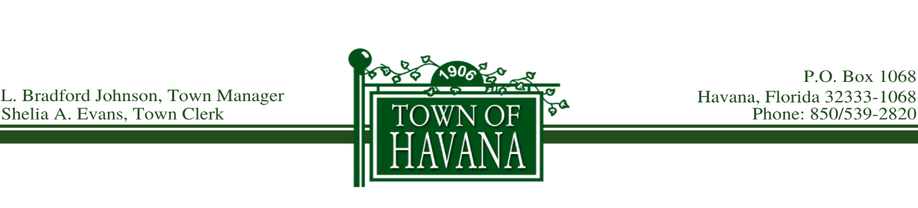

Agenda
Final Public Budget Hearing
September 30, 2020 @ 5:30 p.m.

Call to order by Mayor Allen

Final Reading of Ordinance No. 384, Proposed Ad Valorem Tax Rate

Recognition of any visitor(s) who would like to address the Council on the Ad Valorem Tax Rate

Approve Final Reading of Ordinance No. 384

Final Reading of Ordinance No. 385, Proposed Budget for 2020 2021

Recognition of any visitor(s) who would like to address the Council on the Proposed Budget

Approve Final Reading of Ordinance No. 385

Motion to Adjourn

