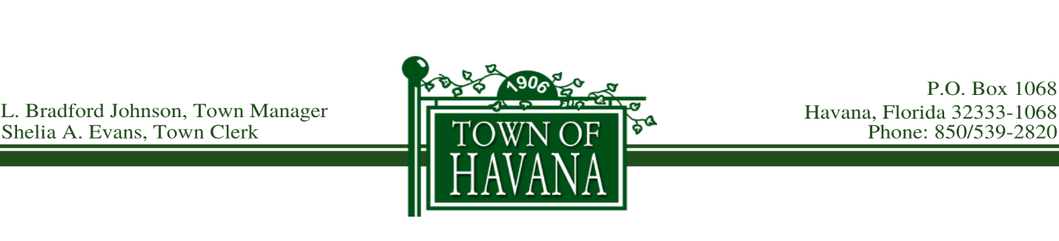
Agenda
Final Public Budget Hearing
September 21, 2021 @ 5:30 p.m.

Call to order by Mayor Hart

Invocation

Pledge of Allegiance

Final Reading of Ordinance No. 389, Proposed Ad Valorem Tax Rate

Recognition of any visitor(s) who would like to address the Council on the Ad Valorem Tax Rate

Approve Final Reading of Ordinance No. 389

Final Reading of Ordinance No. 390, Proposed Budget for 2021 - 2022

Recognition of any visitor(s) who would like to address the Council on the Proposed Budget

Approve Final Reading of Ordinance No. 390

Motion to Adjourn

