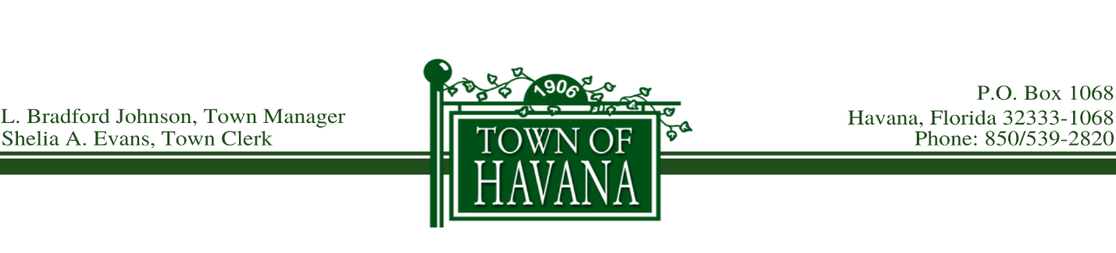
AGENDA
HAVANA TOWN COUNCIL MEETING
November 17, 2020 6:00 PM

Call to Order

Invocation

Pledge of Allegiance

Approval of Minutes – October 27, 2020 Regular Council Meeting

Recognition of Visitors:
(Limit comments to 3 minutes)

Old Business:

New Business:
- Presentation to Mayor Decorkus Allen, Northwest Florida League of Cities 2020 Gene Wright Municipal Resilience Award
- Approval of Appointment to Town Council, Group 1 Vacancy
- Request to Approve the Gadsden County Development Council (GCDC) Annual Investment
- Request to Approve Special Events Form, Havana Main Street Winter Fest Parade
- Request to Approve Special Events Form, Blessings of Hope Empowerment Outreach, Food Giveaway at Town Hall on November 21, 2020
- Request to Approve Special Events Form, Blessings of Hope Empowerment Outreach, Food Giveaway at Havana Community Center, December 5, 2020

Report of the Town Manager:

Recognition of Each Council:

Approval of Bills for Payment

Motion to Adjourn

